TASK:1
Implementation of Graph search algorithms (Breadth first search and Depth First Search)
using following constraints.
Aim: To Implement of Graph search algorithms (Breadth first search and Depth
First Search) using Python.
Task 1A
Algorithm:
BFS
Step 1: Start by putting any one of the graph’s vertices at the back of the queue.
Step 2: Now take the front item of the queue and add it to the visited list.
Step 3: Create a list of that vertex's adjacent nodes. Add those which are not within the
visited list to the rear of the queue.
Step 4: Keep continuing steps two and three till the queue is empty.
PROGRAM
from collections import deque
def bfs(graph, start):
queue, visited = deque([start]), set()
print("BFS Traversal:", end=" ")
while queue:
node = queue.popleft()
if node not in visited:
print(node, end=" ")
visited.add(node)
queue.extend(neighbor for neighbor in graph[node] if neighbor not in visited)
print()
graph = {
'A': ['C', 'B'],
'B': ['A', 'E', 'D'],
'C': ['A', 'F'],
'D': ['B'],
'E': ['B', 'F'],
'F': ['C', 'E']
}

# Starting from A
bfs(graph, 'A')

OUTPUT
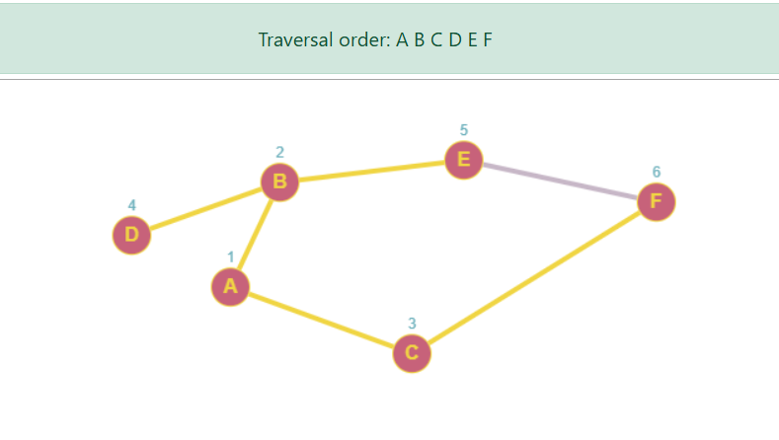
BFS Traversal: A B C D E F

Task1 b
Algorithm DFS –
Step 1: Declare a queue and insert the starting Vertex.
Step 2: Initialize a visited array and mark the starting Vertex as visited.
Step3: Remove the First vertex of queue.
Step 4: Mark that vertex as visited
Step 5: Insert all the unvisited neighbors of the vertex into queue.
Step 6: stop.

PROGRAM
from collections import deque
def dfs(graph, start):
stack, visited = [start], set()
print("DFS Traversal:", end=" ")
while stack:
node = stack.pop()
if node not in visited:
print(node, end=" ")
visited.add(node)
stack.extend(reversed([neighbor for neighbor in graph[node] if neighbor not in visited]))
print()

graph = {
'1': ['2', '3'],
'2': ['1', '4', '5'],
'3': ['1', '6'],
'4': ['2', '7'],
'5': ['2', '6'],
'6': ['3', '5'],
'7': ['4']
}
dfs(graph, '1')

OUTPUT
DFS Traversal: 1 2 4 7 5 6 3
